Steve Gladis Leadership Partners
Press History:
2010 Virginia Tech National Capital Region Commencement | 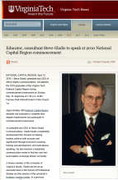 | http://www.vtnews.vt.edu/articles/2010/04/2010-278.html
Library of Professional Coaching: Book Review on Resonant Leadership | 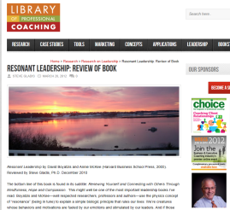 | http://libraryofprofessionalcoaching.com/research/leadership/resonant-leadership-review-of-book/
iMADdu Apprentice Sponsorship |  | http://www.prlog.org/11406592-imaddu-and-steve-gladis-leadership-provide-opportunities-to-empower-student-entrepreneurs.html
Philanthropy Matters: Fairfax County Chamber of Commerce Member Profile | 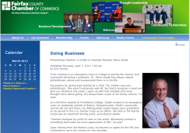 | http://www.fairfaxchamber.org/index.php?src=news&refno=195&category=Doing+Business+&prid=195
Cleveland West Road Runners Club: Steve Gladis Award | 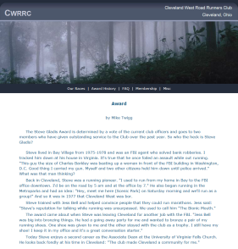 | http://www.cwrrc.org/stevegladis.htm
Washington Exec—Steve Gladis Secret to Success: Attitude, Not Aptitude, With Altitude | 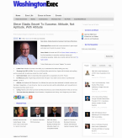 | http://www.washingtonexec.com/2011/09/steve-gladis-secret-to-success-attitude-not-aptitude-with-altitude/
Steve Gladis Leadership Puts New Spin on Tough Talks in 30-Second Rap | 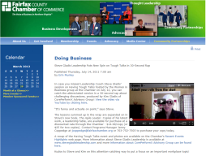 | http://www.fairfaxchamber.org/news/2011/07/14/doing-business/steve-gladis-leadership-puts-new-spin-on-tough-talks-in-30-second-rap/
CorePerformX Blog Post on Philanthropy Matters | 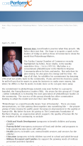 | http://coreperformx.com/?p=712
Fairfax Times: Young business executives embrace the value of giving back | 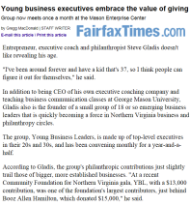 | http://ww2.fairfaxtimes.com/cms/story.php?id=3454
Leadership Fairfax: 2011 Contributing Sponsors | 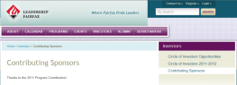 | http://www.leadershipfairfax.org/pages/page.asp?page_id=135805
George Mason Patriot Entrepreneur Member Article | 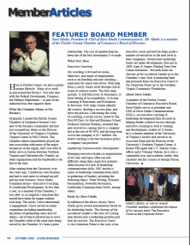 | http://patriotentrepreneur.gmu.edu/images/oct_2008/SteveGladis.pdf

